DiAs - How to

Main screen:
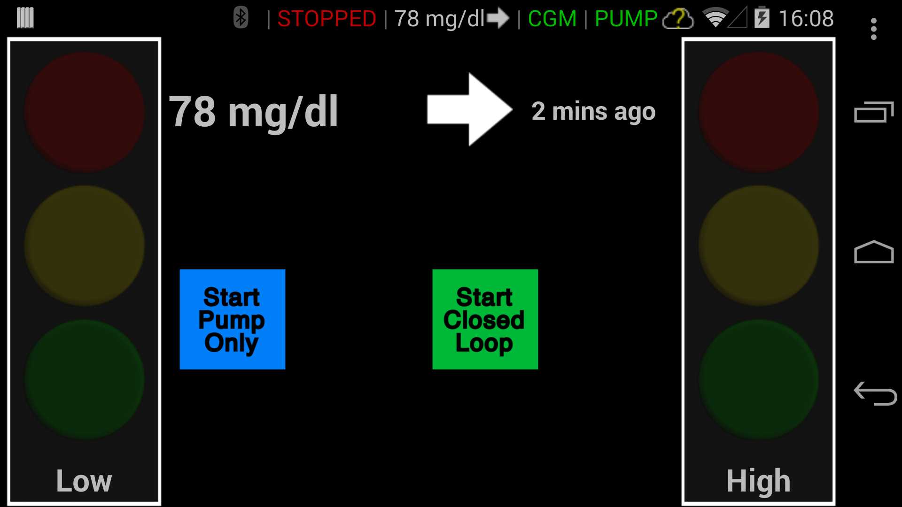
- Go to “Pump Only” or “Closed Loop”
- Upper bar menu: CurrentMode || CGM Value || CGM || PUMP

Access the menu from the main screen: how to navigate to the devices connections
- Press the “three dots” button in the upper right corner of the main screen
- Open the “Device Manager” menu

There are applications for all the devices. In our case, we use three of them:
- Dexcom share - to check that the glucose sensor is connected
- Tandem t:slim - to connect to the pump
- Zephyr Bihoarness - to connect to the harness and verify it is working (you should see some information regarding the activity sensor, including the battery)

Connect to the Internet
- Press the “three dots” button in the upper right corner of the main screen
- Open the “Device Manager” menu
- There should be again a “three dots” button in the upper right corner. Press it
- A new submenu/list opens: you should see Wifi option in the list

Go to DiAS Bluetooth menu
- Press the “three dots” button in the upper right corner of the main screen
- Open the “Device Manager” menu
- There should be again a “three dots” button in the upper right corner. Press it
- To access the Bluetooth menu, select the BT option of the list

How to connect to Dexcom receiver:
- Try to reconnect to Dexcom using Dias app

- Press the “three dots” button in the upper right corner of the main screen
- Open the “Device Manager” Menu
- Open Dexcom share application (it should be one of the last options)
- There is not much to do here, but you can see if the device is correctly paired (and sometimes Dexcom connects just like this).

- If the previous reconnect fail, try to pair Dexcom reciever again
Before trying to re-connect:
Set the Dexcom receiver to connect via Bluetooth:
- Go to settings, and the to Share
- If bluetooth is ON: turn bluetooth off, forget the paired device, turn bluetooth ON again. Dexcom should tell you it is ready to connect/pair
- If bluetooth is OFF: turn bluetooth ON. Dexcom should tell you it is ready to connect/pair

Make sure the bluetooth sign is blinking in Dexcom main screen (upper left corner)

Make sure DiAs is not paired with any other Dexcom device:
Go to Dias Bluetooth Menu, and unpair any device named DEXCOM

Now, to connect:

- Press the “three dots” button in the upper right corner of the main screen
- Open the “Device Manager” menu
- No you have to move the Dexcom receiver close to the back of the phone: you should hear some “positive” noise indicating that the tag (in the back of the Dexcom) is read and that pairing of the device is complete

How to connect to Tandem receiver:

- Try to re connect using DiAS Tandem app

- Press the “three dots” button in the upper right corner of the main screen
- Open the “Device Manager” Menu
- Open Tandem application (it should be one of the last options)
- Use the Scan/connect button to connect again to the pump

- If the previous fails, try to pair the pump again
Before trying to re-connect:
Set the Tandem pump ready to pair via Bluetooth:
- Go to Bluetooth settings
- Forget any pair devices
- If bluetooth is OFF, turn it ON

You should see the bluetooth sign in the left corner of the main screen (since it is not connected, it should have a grey color)

Make sure DiAs is not paired with the Tandem device:
Go to Dias Bluetooth Menu, and unpair the Tandem device

Now, try to pair the tandem pump again:
- Go to the ‘Device Manager” Menu
- Open tandem application
- Press the scan button
- You should see the tandem pump device appear, on the upper left side of the app. Click on it
- The phone will ask you if you want to pair with this device: say Yes/OK
- It will ask you next to enter a PIN (Check in Tandem screen: it should show you the PIN you need to enter)
- Once the pin is enter correctly, Tandem pump will acknowledge the connection (and you should see the pump connecte on DiAS)

